**26. Create a web page using angular to change the degree program of a student from one**

**branch to another.**

=

**Local Links** : <http://localhost/projects/surbhi/>

<http://localhost/phpmyadmin/tbl_structure.php?db=crud&table=crud>

**Deployed links :**

**Screenshots :**

**Home/view**

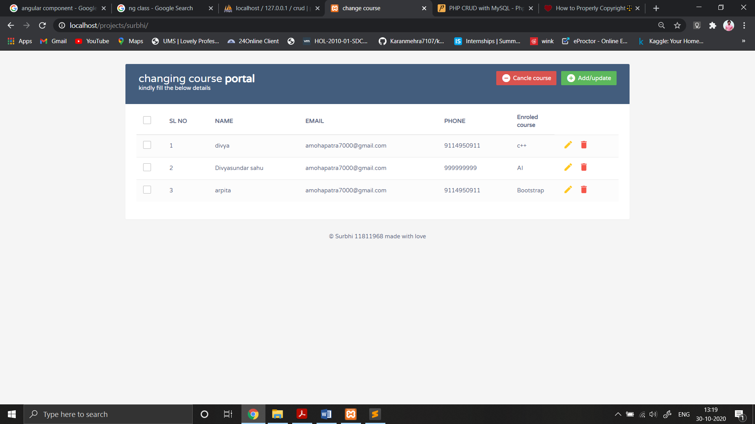

**Add**

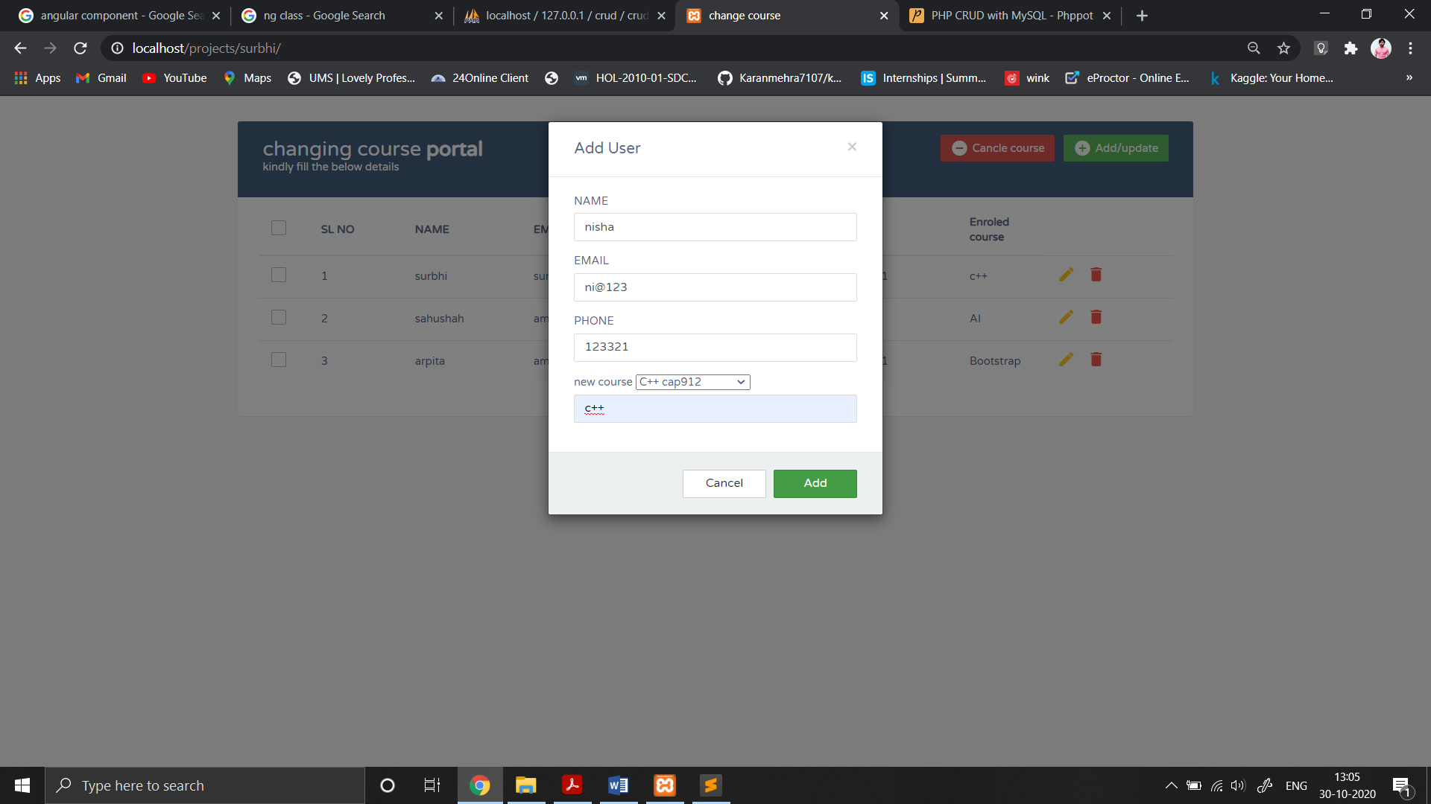

**Edit/update**

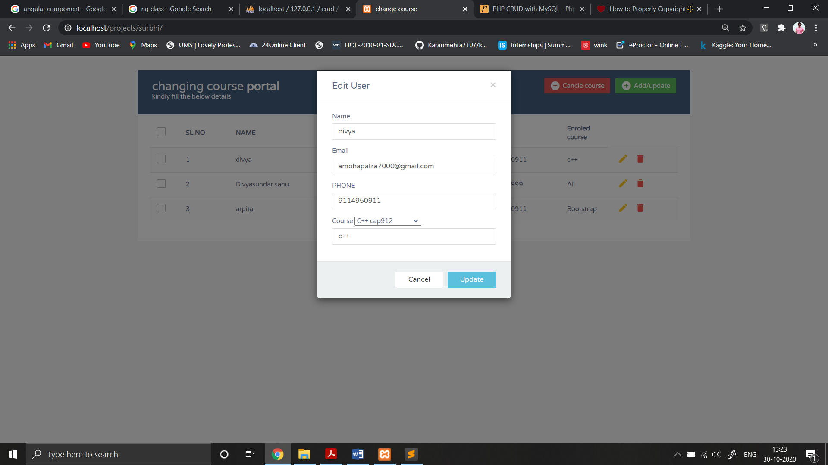

**Drop**

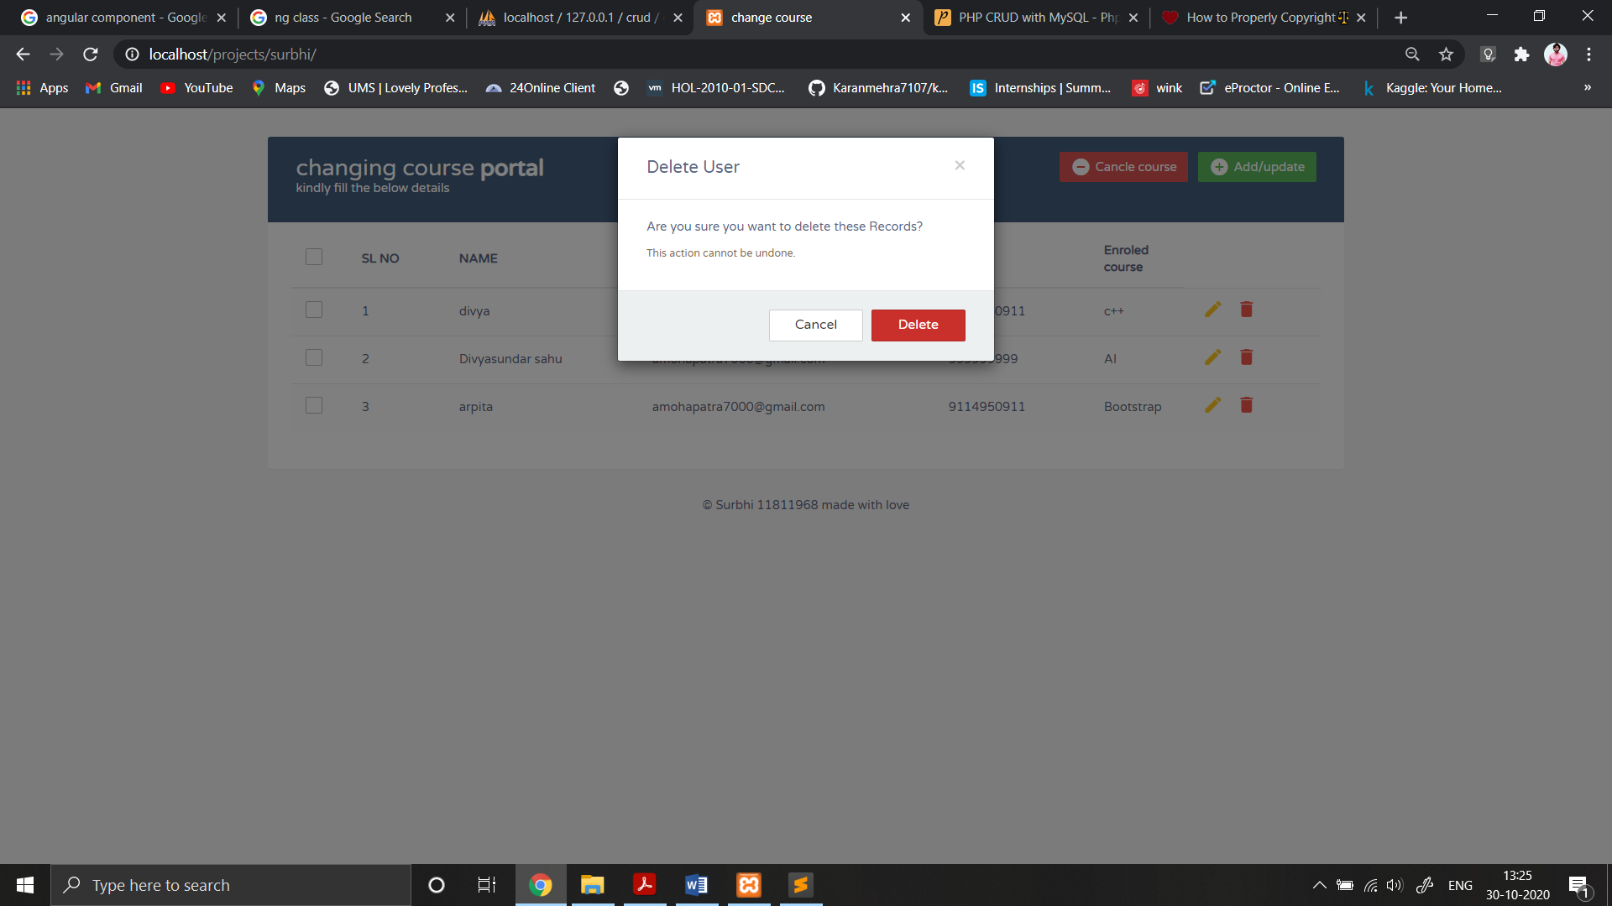

**popup**

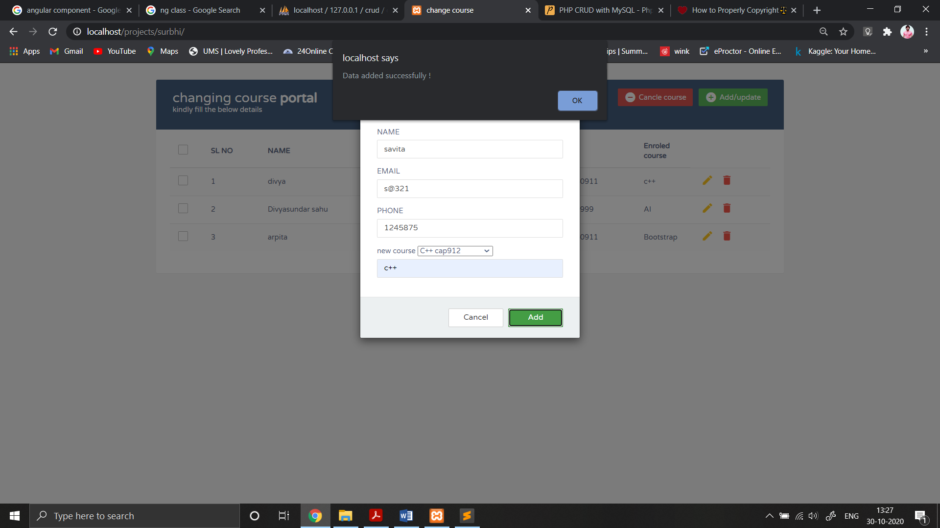

**Server:**

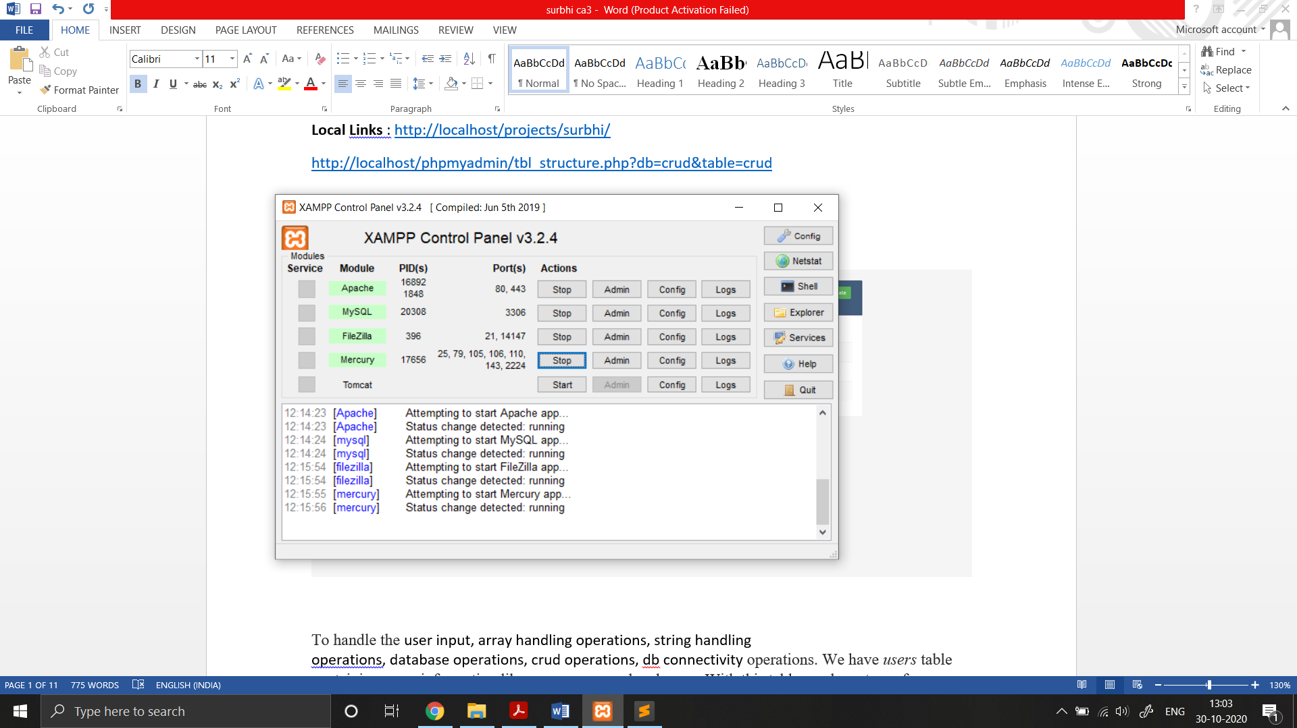

**Admin Structure**

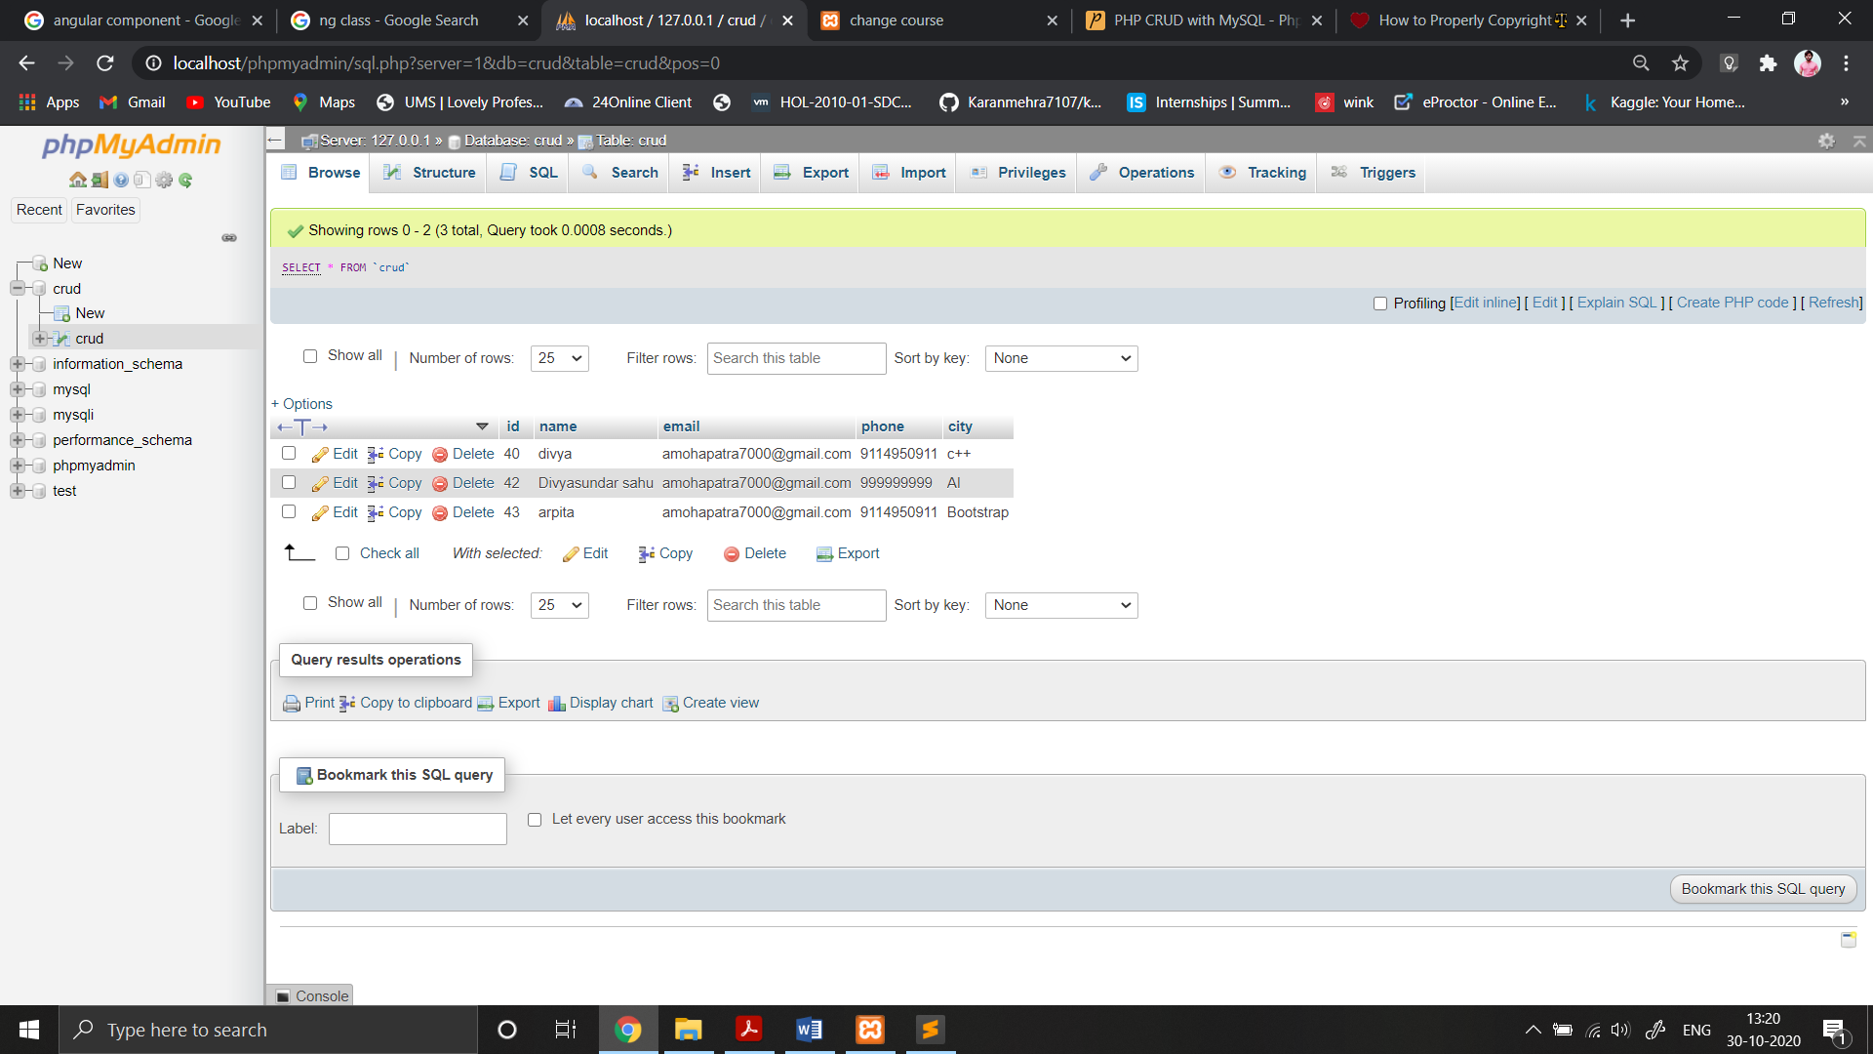

To handle the user input, array handling operations, string handling

operations, database operations, crud operations, db connectivity operations. We have users table containing users information like name, password and more. With this table, we have to perform CRUD.

**Creating New Row in MySQL Database**

The code below is to provide the user interface for the database insert. This HTML form contains input fields to enter user data to be inserted into the table.

<?php

include 'backend/database.php';

?>

<!DOCTYPE html>

<html lang="en">

<head>

<meta charset="utf-8">

<meta http-equiv="X-UA-Compatible" content="IE=edge">

<meta name="viewport" content="width=device-width, initial-scale=1">

<title>change course</title>

<link rel="stylesheet" href="https://fonts.googleapis.com/css?family=Roboto|Varela+Round">

<link rel="stylesheet" href="https://fonts.googleapis.com/icon?family=Material+Icons">

<link rel="stylesheet" href="https://maxcdn.bootstrapcdn.com/font-awesome/4.7.0/css/font-awesome.min.css">

<link rel="stylesheet" href="https://maxcdn.bootstrapcdn.com/bootstrap/3.3.7/css/bootstrap.min.css">

<link rel="stylesheet" href="css/style.css">

<script src="https://ajax.googleapis.com/ajax/libs/jquery/1.12.4/jquery.min.js"></script>

<script src="https://maxcdn.bootstrapcdn.com/bootstrap/3.3.7/js/bootstrap.min.js"></script>

<script src="ajax/ajax.js"></script>

</head>

<body>

<div class="container">

<p id="success"></p>

<div class="table-wrapper">

<div class="table-title">

<div class="row">

<div class="col-sm-6">

<h2>changing course <b>portal</b></h2>

<p> kindly fill the below details </p>

</div>

<div class="col-sm-6">

<a href="#addEmployeeModal" class="btn btn-success" data-toggle="modal"><i class="material-icons">&#xE147;</i> <span>Add/update</span></a>

<a href="JavaScript:void(0);" class="btn btn-danger" id="delete_multiple"><i class="material-icons">&#xE15C;</i> <span>Cancle course</span></a>

</div>

</div>

</div>

<table class="table table-striped table-hover">

<thead>

<tr>

<th>

<span class="custom-checkbox">

<input type="checkbox" id="selectAll">

<label for="selectAll"></label>

</span>

</th>

<th>SL NO</th>

<th>NAME</th>

<th>EMAIL</th>

<th>PHONE</th>

<th>Enroled course</th>

</tr>

</thead>

<tbody>

<?php

$result = mysqli_query($conn,"SELECT * FROM crud");

$i=1;

while($row = mysqli_fetch_array($result)) {

?>

<tr id="<?php echo $row["id"]; ?>">

<td>

<span class="custom-checkbox">

<input type="checkbox" class="user_checkbox" data-user-id="<?php echo $row["id"]; ?>">

<label for="checkbox2"></label>

</span>

</td>

<td><?php echo $i; ?></td>

<td><?php echo $row["name"]; ?></td>

<td><?php echo $row["email"]; ?></td>

<td><?php echo $row["phone"]; ?></td>

<td><?php echo $row["city"]; ?></td>

<td>

<a href="#editEmployeeModal" class="edit" data-toggle="modal">

<i class="material-icons update" data-toggle="tooltip"

data-id="<?php echo $row["id"]; ?>"

data-name="<?php echo $row["name"]; ?>"

data-email="<?php echo $row["email"]; ?>"

data-phone="<?php echo $row["phone"]; ?>"

data-city="<?php echo $row["city"]; ?>"

title="Edit">&#xE254;</i>

</a>

<a href="#deleteEmployeeModal" class="delete" data-id="<?php echo $row["id"]; ?>" data-toggle="modal"><i class="material-icons" data-toggle="tooltip"

title="Delete">&#xE872;</i></a>

</td>

</tr>

<?php

$i++;

}

?>

</tbody>

</table>

</div>

</div>

<!-- Add Modal HTML -->

<div id="addEmployeeModal" class="modal fade">

<div class="modal-dialog">

<div class="modal-content">

<form id="user_form">

<div class="modal-header">

<h4 class="modal-title">Add User</h4>

<button type="button" class="close" data-dismiss="modal" aria-hidden="true">&times;</button>

</div>

<div class="modal-body">

<div class="form-group">

<label>NAME</label>

<input type="text" id="name" name="name" class="form-control" required>

</div>

<div class="form-group">

<label>EMAIL</label>

<input type="email" id="email" name="email" class="form-control" required>

</div>

<div class="form-group">

<label>PHONE</label>

<input type="phone" id="phone" name="phone" class="form-control" required>

</div>

<div class="form-group">

<label>new course</label>

<select name="cars" id="cars">

<option value="volvo">C++ cap912</option>

<option value="saab">AI cap224</option>

<option value="opel">Tableu cap919</option>

<option value="audi">Bootstrap cap917</option>

</select>

<input type="city" id="city" name="city" class="form-control" required>

</div>

</div>

<div class="modal-footer">

<input type="hidden" value="1" name="type">

<input type="button" class="btn btn-default" data-dismiss="modal" value="Cancel">

<button type="button" class="btn btn-success" id="btn-add">Add</button>

</div>

</form>

</div>

</div>

</div>

<!-- Edit Modal HTML -->

<div id="editEmployeeModal" class="modal fade">

<div class="modal-dialog">

<div class="modal-content">

<form id="update_form">

<div class="modal-header">

<h4 class="modal-title">Edit User</h4>

<button type="button" class="close" data-dismiss="modal" aria-hidden="true">&times;</button>

</div>

<div class="modal-body">

<input type="hidden" id="id_u" name="id" class="form-control" required>

<div class="form-group">

<label>Name</label>

<input type="text" id="name_u" name="name" class="form-control" required>

</div>

<div class="form-group">

<label>Email</label>

<input type="email" id="email_u" name="email" class="form-control" required>

</div>

<div class="form-group">

<label>PHONE</label>

<input type="phone" id="phone_u" name="phone" class="form-control" required>

</div>

<div class="form-group">

<label>Course</label>

<select name="cars" id="cars">

<option value="volvo">C++ cap912</option>

<option value="saab">AI cap224</option>

<option value="opel">Tableu cap919</option>

<option value="audi">Bootstrap cap917</option>

</select>

<input type="city" id="city_u" name="city" class="form-control" required>

</div>

</div>

<div class="modal-footer">

<input type="hidden" value="2" name="type">

<input type="button" class="btn btn-default" data-dismiss="modal" value="Cancel">

<button type="button" class="btn btn-info" id="update">Update</button>

</div>

</form>

</div>

</div>

</div>

<!-- Delete Modal HTML -->

<div id="deleteEmployeeModal" class="modal fade">

<div class="modal-dialog">

<div class="modal-content">

<form>

<div class="modal-header">

<h4 class="modal-title">Delete User</h4>

<button type="button" class="close" data-dismiss="modal" aria-hidden="true">&times;</button>

</div>

<div class="modal-body">

<input type="hidden" id="id_d" name="id" class="form-control">

<p>Are you sure you want to delete these Records?</p>

<p class="text-warning"><small>This action cannot be undone.</small></p>

</div>

<div class="modal-footer">

<input type="button" class="btn btn-default" data-dismiss="modal" value="Cancel">

<button type="button" class="btn btn-danger" id="delete">Delete</button>

</div>

</form>

</div>

</div>

</div>

</body>

</html>

On submitting this form the following PHP code create INSERT query with the form fields and fire this query to add new record into database.

SET SQL_MODE = "NO_AUTO_VALUE_ON_ZERO";

SET AUTOCOMMIT = 0;

START TRANSACTION;

SET time_zone = "+00:00";

--

-- Database: `user`

--

-- --------------------------------------------------------

--

-- Table structure for table `crud`

--

CREATE TABLE `crud` (

`id` int(11) NOT NULL,

`name` varchar(60) NOT NULL,

`email` varchar(30) NOT NULL,

`phone` varchar(20) NOT NULL,

`city` varchar(20) NOT NULL

) ENGINE=InnoDB DEFAULT CHARSET=latin1;

--

-- Dumping data for table `crud`

--

INSERT INTO `crud` (`id`, `name`, `email`, `phone`, `city`) VALUES

(40, 'divya', 'amohapatra7000@gmail.com', '9114950911', 'balasore'),

--

-- Indexes for dumped tables

--

--

-- Indexes for table `crud`

--

ALTER TABLE `crud`

ADD PRIMARY KEY (`id`);

--

-- AUTO_INCREMENT for dumped tables

--

--

-- AUTO_INCREMENT for table `crud`

--

ALTER TABLE `crud`

MODIFY `id` int(11) NOT NULL AUTO_INCREMENT, AUTO_INCREMENT=44;

COMMIT;

**Database.php**

<?php

$servername = "localhost";

$username = "root";

$password = "";

$dbname = "crud";

// Create connection

$conn = new mysqli("localhost", "root", "", "crud",);

// Check connection

if (!$conn) {

die("Connection failed: " . mysqli_connect_error());

}

?>

**Save.php**

<?php

include 'database.php';

if(count($_POST)>0){

if($_POST['type']==1){

$name=$_POST['name'];

$email=$_POST['email'];

$phone=$_POST['phone'];

$city=$_POST['city'];

$sql = "INSERT INTO `crud`( `name`, `email`,`phone`,`city`)

VALUES ('$name','$email','$phone','$city')";

if (mysqli_query($conn, $sql)) {

echo json_encode(array("statusCode"=>200));

}

else {

echo "Error: " . $sql . "<br>" . mysqli_error($conn);

}

mysqli_close($conn);

}

}

if(count($_POST)>0){

if($_POST['type']==2){

$id=$_POST['id'];

$name=$_POST['name'];

$email=$_POST['email'];

$phone=$_POST['phone'];

$city=$_POST['city'];

$sql = "UPDATE `crud` SET `name`='$name',`email`='$email',`phone`='$phone',`city`='$city' WHERE id=$id";

if (mysqli_query($conn, $sql)) {

echo json_encode(array("statusCode"=>200));

}

else {

echo "Error: " . $sql . "<br>" . mysqli_error($conn);

}

mysqli_close($conn);

}

}

if(count($_POST)>0){

if($_POST['type']==3){

$id=$_POST['id'];

$sql = "DELETE FROM `crud` WHERE id=$id ";

if (mysqli_query($conn, $sql)) {

echo $id;

}

else {

echo "Error: " . $sql . "<br>" . mysqli_error($conn);

}

mysqli_close($conn);

}

}

if(count($_POST)>0){

if($_POST['type']==4){

$id=$_POST['id'];

$sql = "DELETE FROM crud WHERE id in ($id)";

if (mysqli_query($conn, $sql)) {

echo $id;

}

else {

echo "Error: " . $sql . "<br>" . mysqli_error($conn);

}

mysqli_close($conn);

}

}

?>